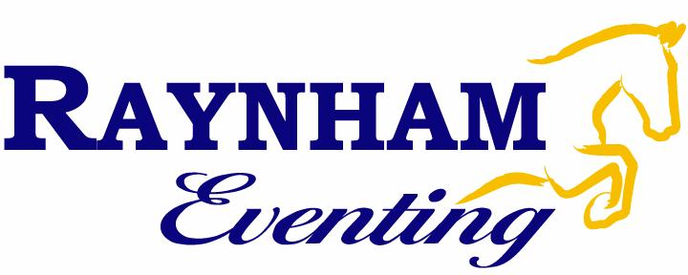
2020 Show Selection Form

 | Date | Show | Levels
★ | April 25th | Raynham Combined Test | T, PT, E, PE
 | May 13 (WED) | Glen Oro CT & XC School | P, T, PT, E, PE
 | May 16-17 | RCRA CT & Dressage Show | T, PT, E, PE
 | May 24 | Grandview Horse Trials | I, P, T, PT, E, PE
 | May 29-31 | Caledon Spring Jubilee @ Palgrave | Gold/Platinum
 | May 30-31 | Eventing Kindergarten @ Wits End | Tadpole-Training
 | June 7 | Foxcroft Equestrian CT | 18”-3’7
 | June 11-14 | Kawartha Summer Classic @ RCRA | Silver-Platinum
 | June 14 | Caledon Horse Trials | T, PT, E, PE
 | June 19-21 | Caledon Dressage @ Angelstone | Gold
 | June 20 | Cherrylane Horse Trials #1 | IP, P, T, PT, E, PE
 | June 20-21 | Wits End Eventing Kindergarten | Tadpole-Training
 | June 26-28 | Cedar Valley Summer Classic | Gold
 | June 28 | Dreamcrest Horse Trials | P, T, PT, E, PE
 | July 1 | Foxcroft Equestrian CT | Tadpole-Training
 | July 4-5 | Willowind Horse Trials | I, P, T, PT, E, PE
 | July 10-12 | Caledon Dressage @ Angelstone | Gold
 | July 12 | Bronte Creek Horse Trials | IP, P, T, PT, E, PE
 | July 18 | Grandview Horse Trials | I, P, T, PT, E, PE
 | July 24-26 | Caledon Salute to Dressage (Palgrave) | Gold
 | July 25 | Glenarden Horse Trials | TP, T, PT, E, PE
 | July 26 | Cabra Park Stables CT | Tadpole-Training
 | Aug 2 | Glen Oro Summer Horse Trials | I, P, T, PT, E, PE
 | Aug 8-9 | Wits End Eventing Kindergarten | Tadpole-Training
 | Aug 14-16 | Bromont CCI-S, Horse Trials- FEI Evening Nations Cup
 | Aug 22 | Wits End Horse Trials | I, P, T, PT, E, PE
 | Aug 23 | Cabra Park Stables CT | Tadpole-Training
 | Aug 25-29 | Dressage Champs @ Essa Agriplex | Bronze-Gold
 | Aug 29 | Cherrylane Horse Trials # 2 | P, T, PT, E, PE
 | Sept 3-6 | CCI Foshay International
 | Sept 13 | Glen Oro Horse Trials | I, P, T, PT, E, PE
 | Sept 20 | Bronte Creek Horse Trials | IP, P, T, PT, E, PE
 | Sept 26 | Grandview Horse Trials | P, T, PT, E, PE
 | Sept 26-27 | RCRA Fall Dressage Show | Bronze-Gold
 | Oct 4 | Will O’ Wind Fall Finale | I, P, PT, E, PE
 | Oct 10 | Glenarden Fall Horse Trials | TP, PT, E, PE
 | Oct 17-18 | Wits End Eventing Kindergarten | Tadpole-Training
 | Oct 24-25 | RCRA Fall Dressage Show | Bronze-Gold
 | Oct 29 – Nov 1 | Virginia Horse Trials | CCI*** - BN
 | Nov 21-22 | RCRA Fall Dressage Show | Bronze-Gold

2020 Show Selection Form
PLEASE FILL OUT AND RETURN TO THE CHEQUE BOX BY MARCH 16th

Rider Name: ______________________________________________________
Horse Competing: _________________________________________________
Show team riders are guaranteed 6 shows. We may be able to give riders more, depending on how the schedule works out. How many shows would you like, ideally?
Total # of Shows: _________________________
Other Comments/Requests: __________________________________________
________________________________________________________________________________________________________________________________________
Please check off ALL SHOWS on the following page that you are available for. If there is a specific show or date that you prefer, please mark those with a star ★ and then check ✓ all other date that you are available for but are second choices. If there are dates that you are NOT available, please put a line through that row. Please circle the level at which you would like to compete at for each competition. This will ultimately be up to your coach but we would like to know your goals for the season!

PLEASE NOTE THAT THIS DOES NOT GUARANTEE YOU THESE SHOWS. We will use this information to put together a schedule that will meet everyone’s needs as well as balancing the horse’s workloads and spaces on the trailer. You will receive confirmation of your show dates by early April. Don’t forget to mark your calendar for our Show Team Clinic on Friday, April 24th where rider will learn about show prep, packing, rules, etc. The Spring Combined Test on April 25th will be full dress so that riders can practice their braiding skills and test out show clothes!

Once your dates are confirmed, you are booking a space on the trailer. If you are unable to attend any of your scheduled shows, you are still obligated to pay for your spot on the trailer ($100+HST) unless we can fill your spot with another rider or schedule you into another show. If you can provide a medical certificate to explain your absence, we will waive this fee. If you are show boarding and your horse is lame, we will our best to offer an appropriate replacement horse. If you refuse, you will still owe the cancellation fee. If a replacement horse is not available, we will waive the fee.

Legend
Combined Tests, Short Courses, Unrecognized Horse Trials, or Jumpers
Ontario Horse Trial
Horse Trial in the USA/Long Distance (additional fees apply)
Dressage Show

